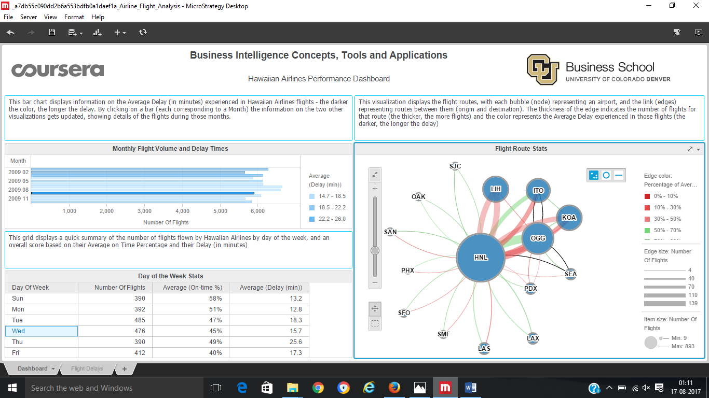

Ans: Confidence is that you get an on-time flight at around 45%

And time delay is about 15.7 min